PRE-EXPERIMENT QUIZ

- Derive the relation 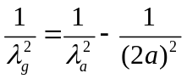 for a rectangular waveguide.
- What is the cut-off wavelength for a rectangular waveguide?
- What modification, if any, may be required in the relation in question 1, for a circular waveguide?
- Rewrite the relation in question 1 so that it holds good for any mode supported by a rectangular waveguide.

